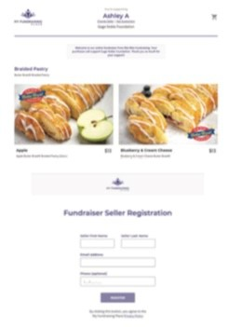
 HOW TO SET UP YOUR FUNDRAISER ONLINE STORE
Step 1: Self Register Your Online Sale
Scan the QR Code from the participant’s
letter. Fill out the required information
for your online fundraiser. After you
register, you will be directed to your
own personal online fundraising page.

Step 2: Promote Your Sale
Use the icons on your page to promote your sale on various
social media platforms….via text, social media, or email!
Tip: Be sure to include what you are raising money for.


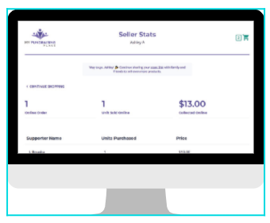
Step 3: Track Your Progress
Click “See Supporters” to view
your Stats to see the total
of units you have sold.

Step 4: Deliver Your Orders
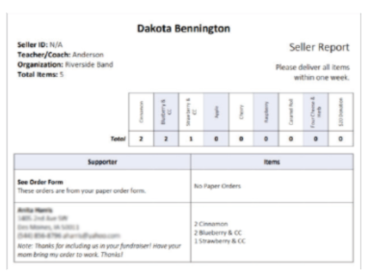

At the end of your fundraiser, orders will arrive prepacked at designated location determined by your group leader. You will receive a report with your supporter’s online order information inside your box so you can deliver their orders. Don’t forget to thank your
supporters!

