

Dear Parent/Guardians & Community Members:
We are excited to offer the ZBest Dining & Entertainment Evergreen Discount Card & Coupons for our fundraiser.
40% ($10.00) of every card sold supports (Enter Purpose)

Each Evergreen Discount Card includes hundreds of dollars in savings at local restaurants, entertainment venues, and services - the perfect gift for only $25

Prefer to order with cash?
Collect $25 for each card, place it in the envelope, and fill out the order form.
Checks should be made payable to (Enter organization name)

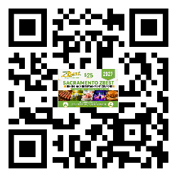
View & Purchase Sacramento Coupons

Share the QR Codes with your Family, Friends, Neighbors & Co-Workers and give them the gift that gives back!
Important Information & Dates
Fundraiser Begins: (Enter Date)
Fundraiser Ends: (Enter Date)
Delivery Date: (Enter Date)
Delivery Location: (Enter Location)
Questions? Email: (Enter Email)
*Please note ALL Online Orders will be delivered to the school for the student to distribute*

THANK YOU FOR YOUR SUPPORT!

